Name __Zhao, Rena______________________ Date: __04/25/22__________

NetID: __ryz215______ Section: __007_________



I have completed this assignment independently:

**Lab 2**

**Total in points** (100 points total): ___________________

**Professor’s Comments:**

**PART 1 BOMB (bomb5)**

**Setting up:**

* objdump -d ./bomb > bomb_execute.txt generates executable disassembled code
* objdump -D ./bomb > bomb_all.txt generates all disassembled code including data sections
* vi mysol.txt creates a solutions file
* gdb ./bomb enters gdb mode

**Phase 1:**

* Setting breakpoints so the bomb doesn’t explode

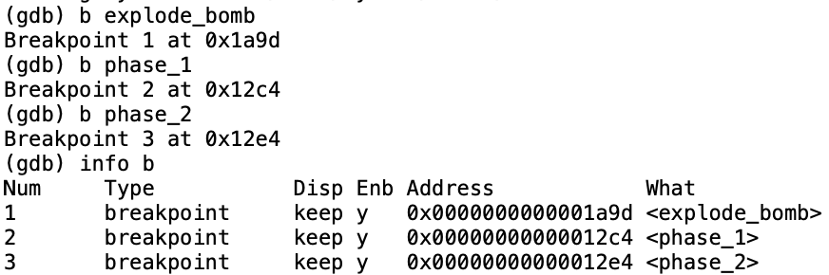

* Assembly code for phase_1 using disas phase_1

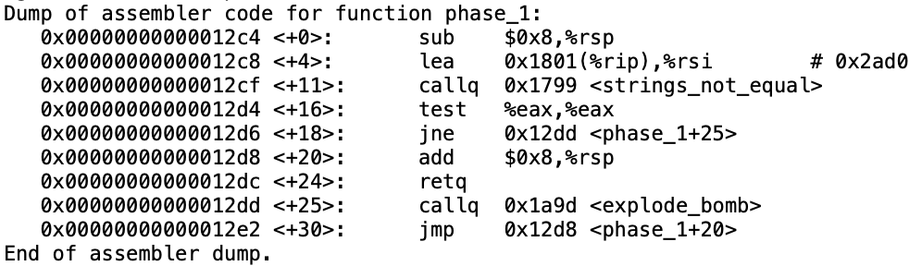

* We notice that the program compares an inputted string with a string stored in memory address 0x2ad0. If the two strings are not equal, then explode_bomb is triggered.
* To find what’s stored at 0x2ad0, we use the print /c command on the memory address. Each address stores a character that is part of the string, so we keep going until we reach a period.
* After calling print /c *0x2ad0, we get $1 = 84 'T'. The first character is ‘T’. Continue with address *0x2ad1, *0x2ad2, and so on.
* We reach a period at *0x2af1. This indicates that our string is complete. It says “There are rumors on the internets.” We input this into the mysol.txt file.
* Run with file input with command run mysol.txt. Pauses at breakpoint at phase_1. Command c continues the code and defuses phase_1.

**Phase 2:**

* Setting breakpoints so the bomb doesn’t explode

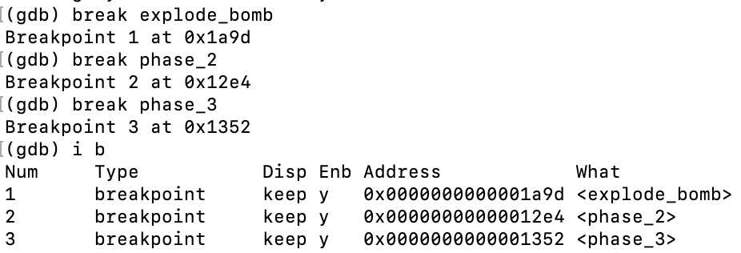

* Run phase_1 with run mysol.txt
* Enter random input after phase_1 is defused to get to phase_2
* Assembly code for phase_2 using disas phase_2

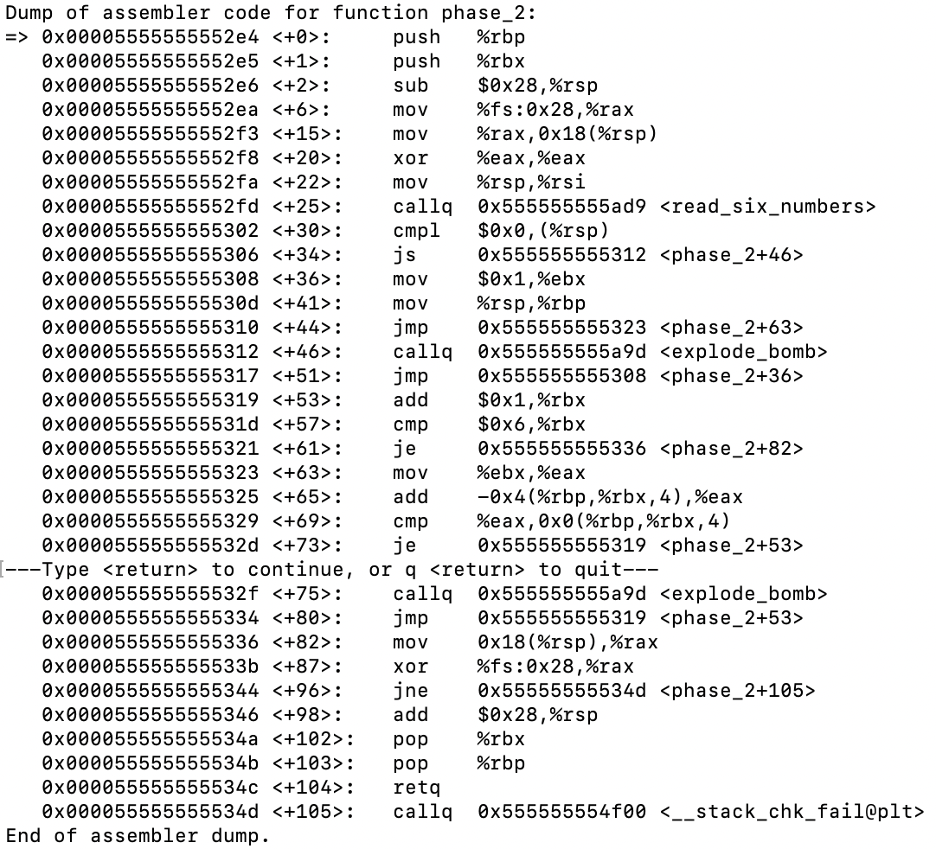

* We see the function <read_six_numbers> and we disassemble using disas read_six_numbers

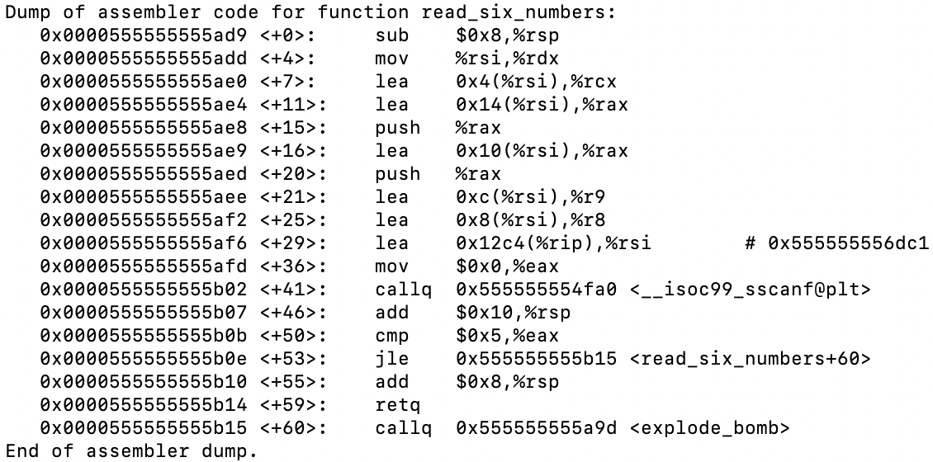

* We notice that there’s something stored in *0x555555556dc1. We can print out what’s there with print /c *0x555555556dc1. After continuing through print /c *0x555555556dd1, we see “%d %d %d %d %d %d”, which is an input of 6 numbers.
* We now kill the program and restart with an input of random numbers “53 26 39 64 35 47”
* Jump to the line after read_six_numbers is called using until *0x0000555555555302
* This line is comparing 0 with what is stored in %rsp, which is 53 right now. The js command in the next line determines that if 53 minus 0 is negative (sets the sign flag), then jump to +46 that calls explode_bomb. Since the result does not set the sign flag, we continue down to +44 which brings us to +63.
* We can notice that lines +53 and +57 look like conditions for a for loop–starting at 1, add 1 during each loop iteration until 6 is reached. When 6 is reached, jump to line +82.
* The loop keeps going through +53 to +73.
* Upon examining the assembly, we find that each result is stored in %eax during each loop iteration. We can update our input with the value of %eax we reach before the explode_bomb breakpoint is reached so we reach more loop iterations that will tell us the next value. We print out the value in %eax using p $eax
  + First try: 1 26 39 64 35 47
  + Second try: 1 2 39 64 35 47
  + Third try: 1 2 4 64 35 47
  + Fourth try: 1 2 4 7 35 47
  + Fifth try: 1 2 4 7 11 47
  + Sixth try: 1 2 4 7 11 16. We input this into the mysol.txt file.
* Alternatively, we can find that the loop is performing a pattern of x[1] = 1; x[i] = x[i – 1] + (i – 1)
* Run with file input with command run mysol.txt. Pauses at breakpoint at phase_2. Command c continues the code and defuses phase_2.

**Phase 3**

* Setting breakpoints so the bomb doesn’t explode

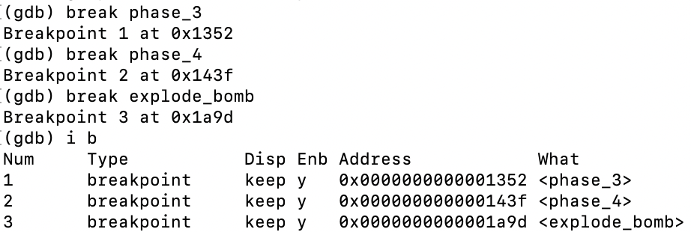

* Run phase_1 and phase_2 with run mysol.txt
* Enter random input after phase_2 is defused to get to phase_3
* Assembly code for phase_3 using disas phase_3

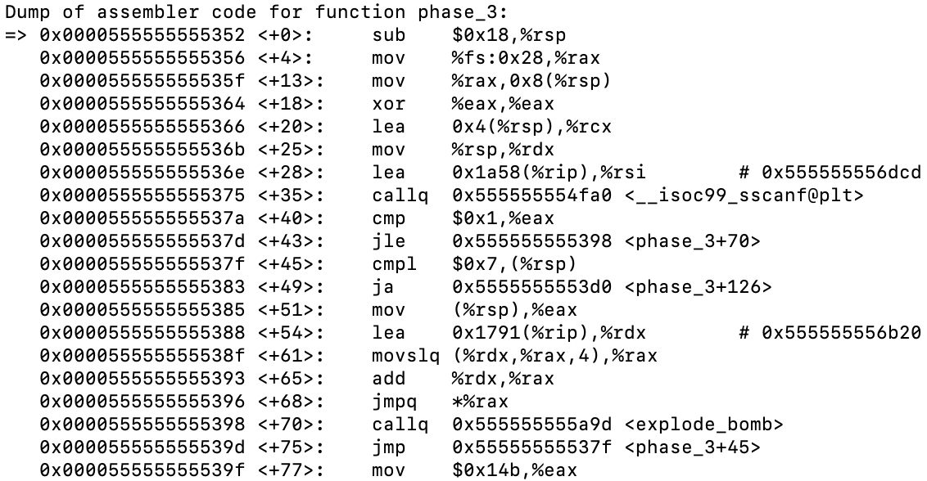

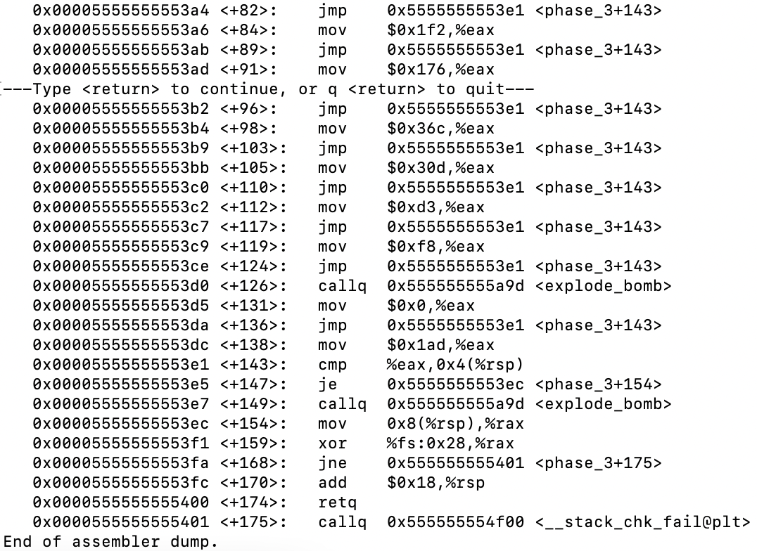

* We see <__isoc99_sscanf@plt> in line +35, which is a call to the scanf function. We know it will be taking in input as a formatted string. In the line above, we notice that there’s something stored in *0x555555556dcd. We can print out what’s there with print /c *0x555555556dcd. After continuing through print /c *0x555555556dd1, we see “%d %d”, which is an input of 2 numbers.
* We can infer from +40 and +45 that the first number is between 2 and 7 since +40 will jump to explode_bomb if the input is less than or equal to 1, and +45 will jump to explode_bomb if the input is above 7. We will choose “5” as the first number in the input.
* We now kill the program and restart with an input of random numbers “5 20”
* Jump to the line after scanf using until *0x000055555555537a
* Use ni to continue through each line
* Line +68 unconditionally jumps straight to +105, then +110 unconditionally jumps to +143, which seems to compare a value in memory address (%rsp + 0x4) to what’s stored in %eax.
* Our input was stored in %rsp, which means that the first number was stored at the address of %rsp, then the second number was stored at the address of $rsp + 0x4. Thus, %eax is being compared to our second number, and if those two are equal, then we can jump over the explode_bomb command.
* We print the value in %eax using p $eax, which is 781. We input 5 781 into the mysol.txt file.
* Run with file input with command run mysol.txt. Pauses at breakpoint at phase_3. Command c continues the code and defuses phase_3.

**Phase 4**

* Set breakpoints at phase_4, phase_5, and explode_bomb so the bomb doesn’t explode
* Run phase_1, phase_2, and phase_3 with run mysol.txt
* Enter random input after phase_3 is defused to get to phase_4
* Assembly code for phase_4 using disas phase_4

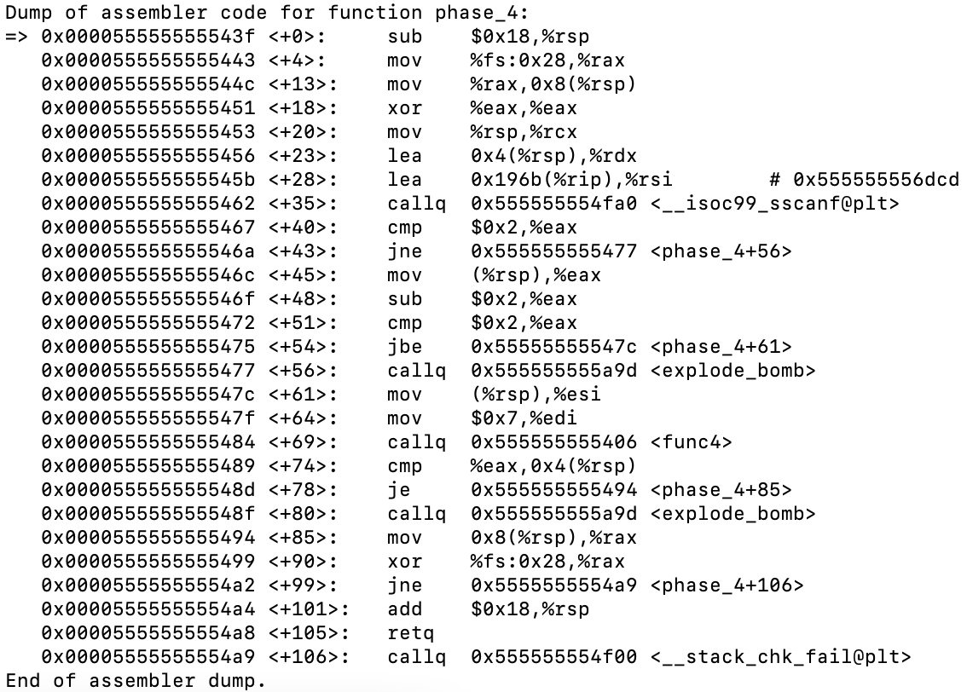

* Same as in phase_3, we see a call to the scanf function as <__isoc99_sscanf@plt> in line +35, and in the line above, we notice that there’s something stored in *0x555555556dcd. Going through the same process as in earlier phases, we see “%d %d”, which is an input of 2 numbers.
* We now kill the program and restart with an input of random numbers “3 9”
* Jump to the line after scanf using until *0x0000555555555467
* Use ni to continue through each line
* Using x/6w $rsp, we see that 9 is stored at (%rsp) 3 is stored at (%rsp + 0x4). The order switched.



* Line +45 moves 9 into %eax and line +48 subtracts 2 from it, giving us 7. Line +51 lets us use any number between 2 and 4 as the second input. We restart using numbers “31 3”
* Line +69 calls a function called <func4>. We disassemble using disas func4

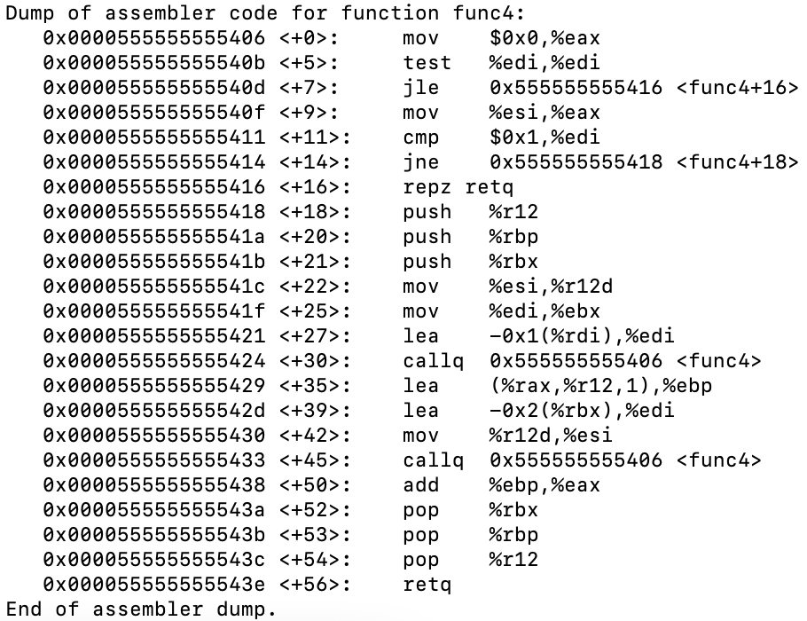



* We can quickly identify that this is a recursive function. We had passed in 0x7 in %edi from phase_4 in line +64. The base case will return %esi if %edi equals 1, which is not true, so we continue for now
* We move our parameters into %r12 and %ebx, then decrement %edi by 1 in line +27. Call func4 and outcome is saved in %rax.
* In line +35, the outcome plus %esi gets saved into %ebp
* Before the second func4 call in line +45, %edi is set to the initial value of %edi minus 2, then %esi is getting set to the previous value of it saved in %r12.
* After the second func4 call, %eax and %ebp are added and stored in %eax in line +50
* However, I found that I didn’t really need to examine func4 that much. We can go back to phase_4 and examine the registers that came out of func4. %rax is the return value of that function, so we use i r to check what it is. It is 99. The value of %eax, which is what the first input is being compared to in line +74, is also 99. We input 99 3 into the mysol.txt file.

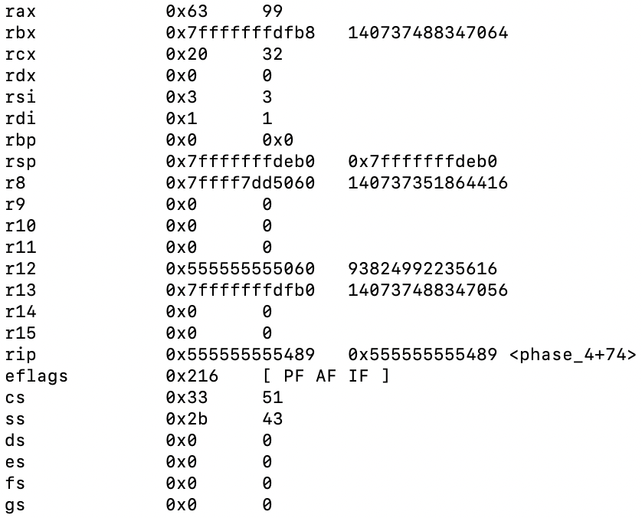

* Run with file input with command run mysol.txt. Pauses at breakpoint at phase_4. Command c continues the code and defuses phase_4.

**Phase 5**

* Set breakpoints at phase_5, phase_6, and explode_bomb so the bomb doesn’t explode
* Run phase_1 through phase_4 with run mysol.txt
* Enter random input after phase_4 is defused to get to phase_5
* Assembly code for phase_5 using disas phase_5

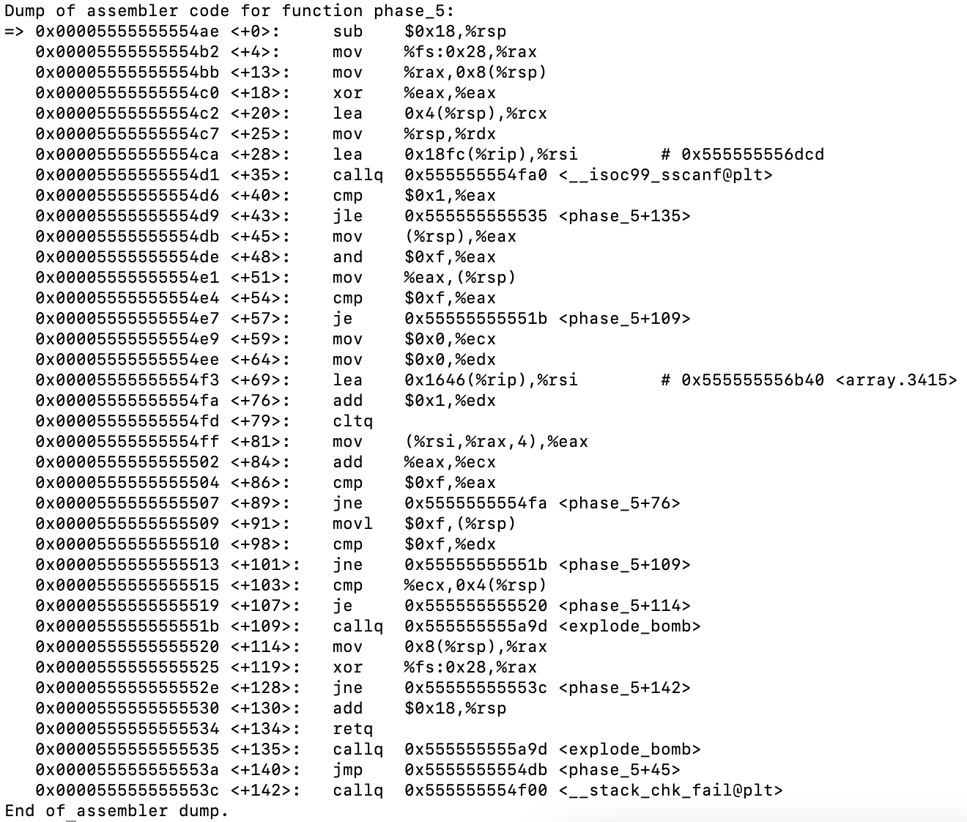



* Same as in phase_3, we see a call to the scanf function as <__isoc99_sscanf@plt> in line +35, and in line +28, we notice that there’s something stored again in *0x555555556dcd. Going through the same process as in earlier phases, we see “%d %d”, which is an input of 2 numbers.
* Upon first examination of the assembly, we see that in line +103 the second input is compared to the value stored in %ecx.
* We’re stuck in a loop from line +76 to +89. The only way to break out of it is to have %eax equal 15 in line +86. Additionally, %edx is the counter for the loop that increments by 1 each time the loop executes. Line +98 shows that we also need it to equal 15 at the time we break out of the loop (15 iterations) or else we will trigger explode_bomb
* Instead of trying to decode the loop, we can try 0-15 as our first input value and a random second value. I had previously tested and concluded that anything above this range provides the same %eax and %edx value as the input number minus 16 (ex. 23 and 39 will provide the same values as 7).
* We test that a first input of 5 provides us with a value of 15 for both %eax and %edx. We rerun the input with “5 7”
* Now we go down to line +103 and find what the value of %ecx is. It is 115. We input 5 115 into the mysol.txt file.
* Run with file input with command run mysol.txt. Pauses at breakpoint at phase_5. Command c continues the code and defuses phase_5.

**Phase 6**

* Set breakpoints at phase_6 and explode_bomb so the bomb doesn’t explode
* Run phase_1 through phase_5 with run mysol.txt
* Enter random input after phase_5 is defused to get to phase_6
* Assembly code for phase_6 using disas phase_6

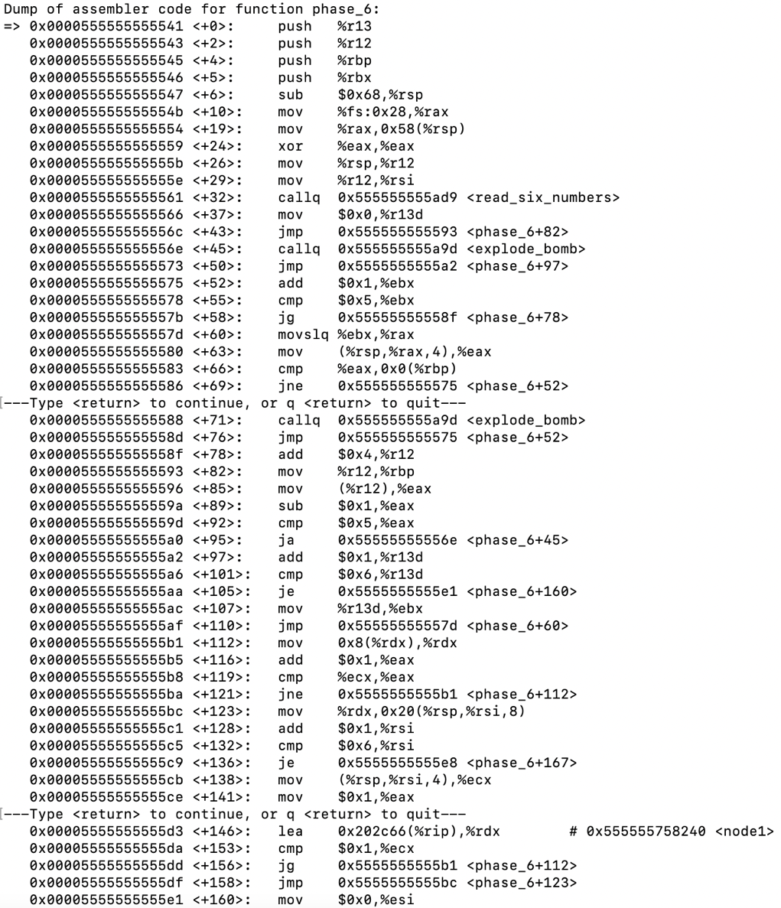

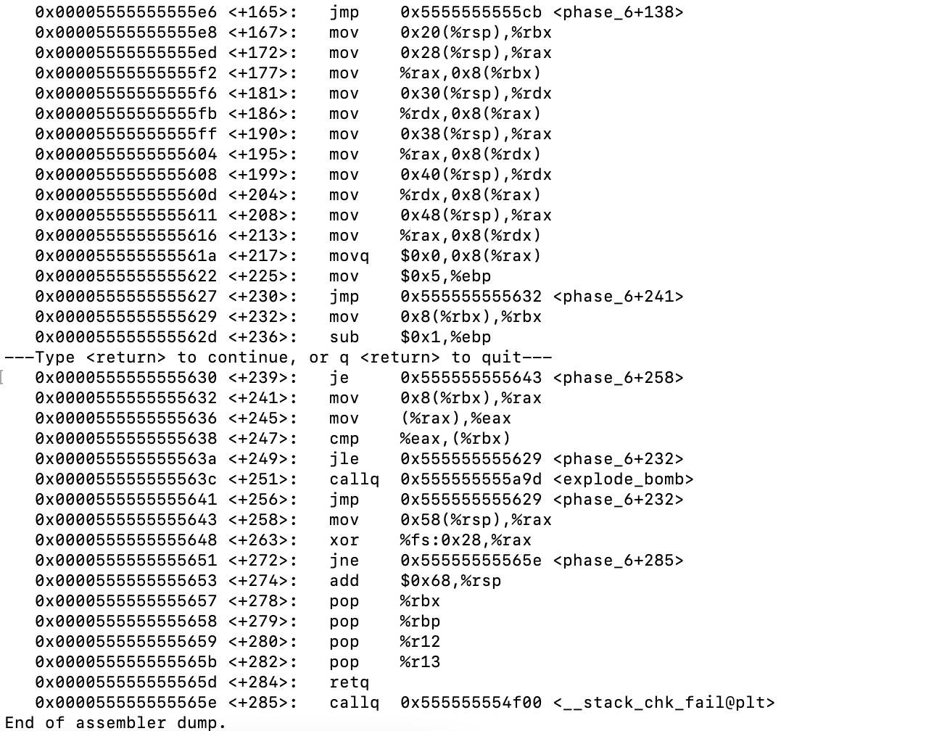

* We see the function <read_six_numbers> and know that the input will “%d %d %d %d %d %d”. We restart the program with an input of random 6 numbers “15 9 67 43 12 8”
* Going down to line +89, we see using i r that %rax stores our input. This line subtracts 1 from our input, then the next line compares this result to 5 and jumps to explode_bomb if it is above. Now we know to keep our input values less than or equal to 6.
* Upon further examining the assembly, we find that we cannot have repeating numbers in the input, or it will call explode_bomb. The compare statement in line +66 will not jump over the call if any two values are equal. We rerun the input with “1 2 3 4 5 6”
* Next, we look at line +146. Using x/12gx 0x555555758240, we can see the hex values in 5 nodes. The first column seems to be integers, and the second is memory addresses.

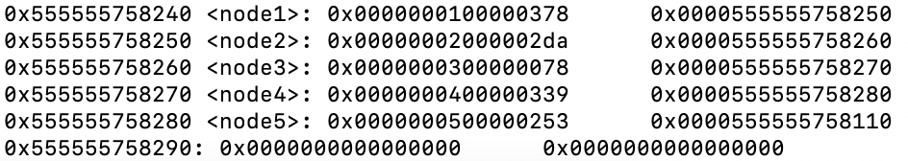

* The first 5 nodes all seem to follow each other, and the address listed in <node5> should lead into to <node6>. Using x/2gx 0x0000555555758110, we find <node6>.



* We can ni through a bunch of lines till we reach a compare/jump statement that could possibly be problematic in line +247. We print the values of %eax and %rbx, which is 730 (0x2da) and the address of the first node, respectively.



* This means that we’re comparing 0x2a with the value in the first node, which is 0x378. This fails because the jump statement needs 0x2a to be less than 0x378.
* We can take a guess and try putting these in numerical order based off of the hex value in the integer (0x78 🡪 0x253 🡪 0x258 🡪 0x2da 🡪 0x339 🡪 0x378). This gives us “3 5 6 2 4 1”. We can quickly test this out with the command n which actually manages to take us to phase_defused(). We input 3 5 6 2 4 1 into the mysol.txt file.
* Run with file input with command run mysol.txt. Pauses at breakpoint at phase_6. Command c continues the code and defuses phase_6.

**Secret Phase**

* We look through bomb_all.txt to see how to access the secret phase. We notice that in phase_defused, there is a call to secret_phase. By setting a breakpoint at phase_defused, we can reach the secret_phase. Also put one at explode_bomb and secret_phase.
* Assembly code for phase_defused using disas phase_defused

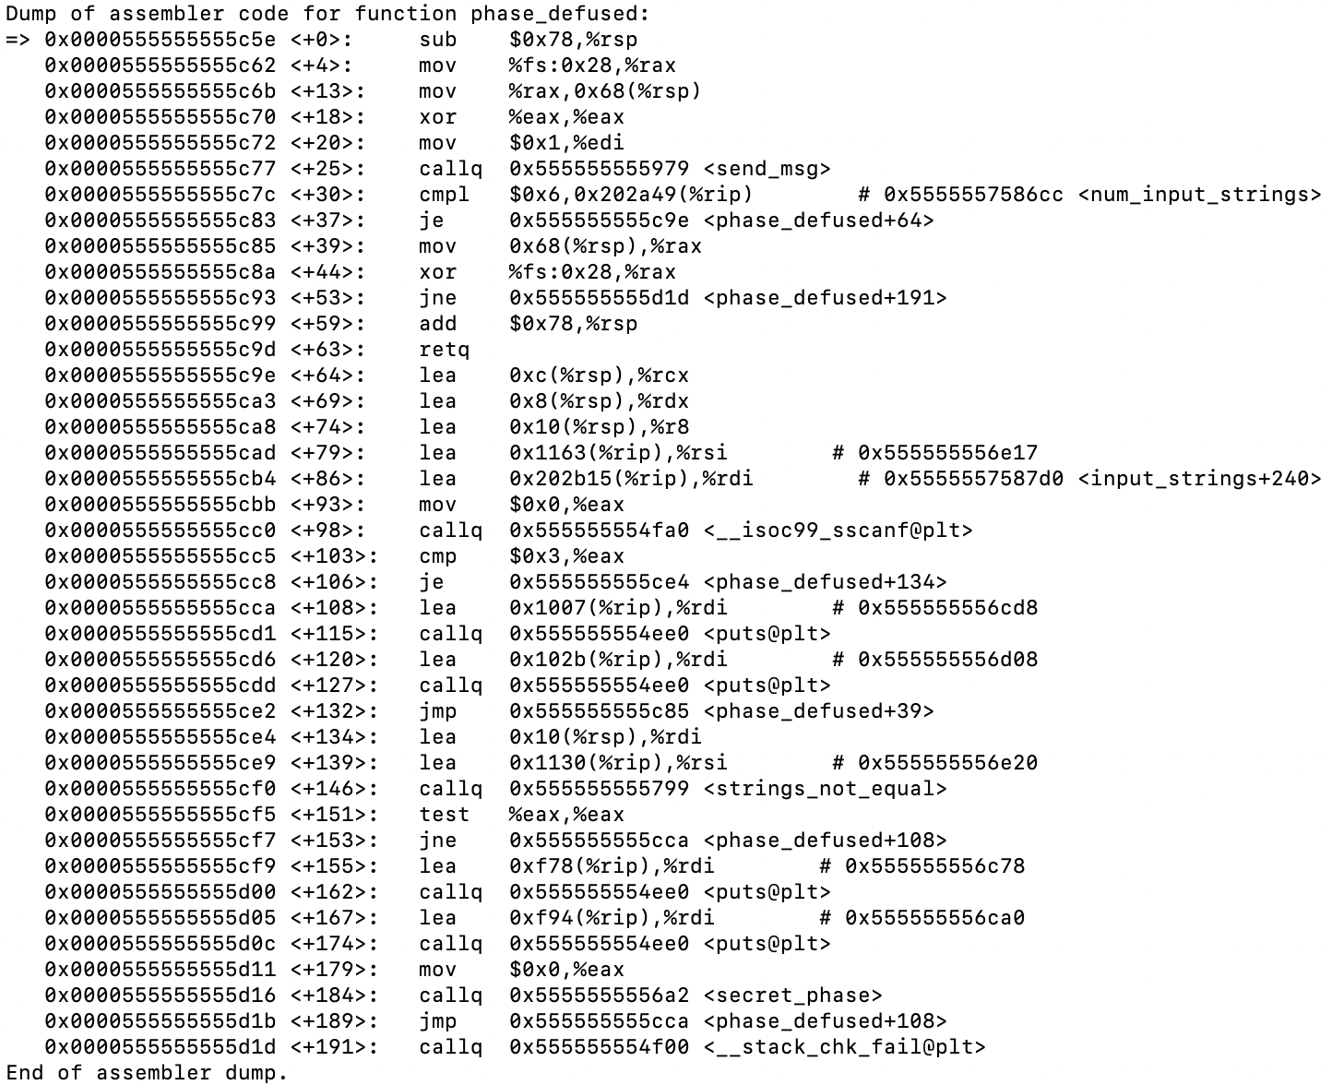



* There’s a lot going on. I just started with printing out all the values that included a #. Two of them stood out to me: x/8bs 0x555555556e17 and x/8bs 0x5555557587d0

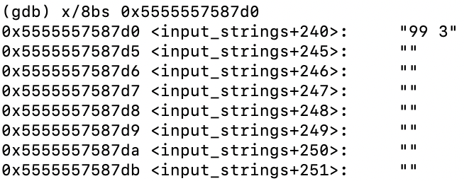 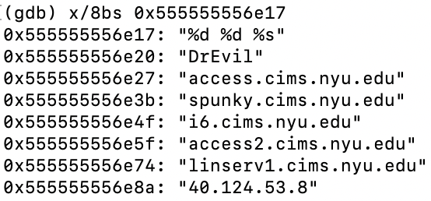

* 99 3 is our input for phase_4. It seems that it may be possible that phase_4 is an input of “%d %d %s”, with “DrEvil” as the string after the two integers we originally had for phase_4
* We continue through the program with manual input for each phase, replacing our original input for phase_4. We reach secret_phase after continuing though phase_defused for phase_6.

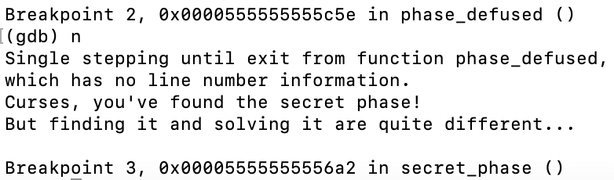

* We disassemble secret_phase

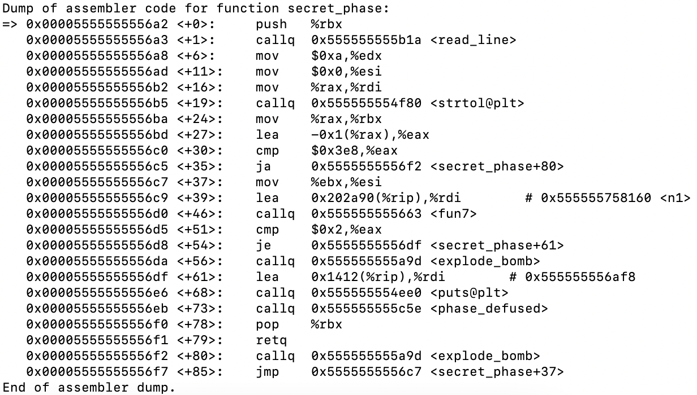

* We see that our input is getting subtracted by 1 in line +27 and is compared to the value 0x3e8 in line +30. If it is greater, then we jump to explode_bomb. This means our input is less than 1000, but also cannot be negative. We choose a random number 6 as the input.
* Line +39 gives us something that looks like a binary tree. We can build the tree by printing out a couple of nodes using x/30g 0x555555758160. For <n1>, 24 is the value in the node; 0x0000555555758180 is the address of the left child; 0x00005555557581a0 is the right child

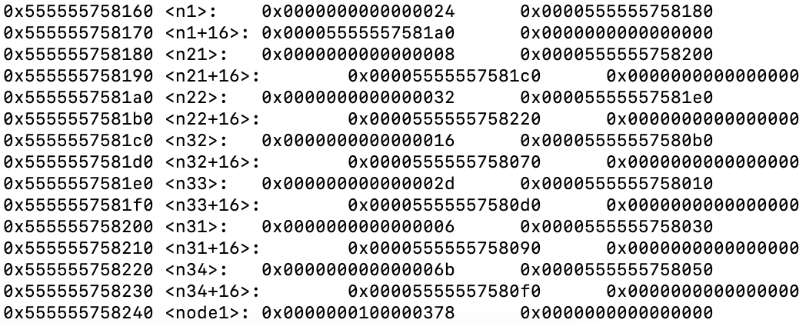

* We can print the rest of the nodes using x/4g [insert address]. Building a BST from this information, we get

0x24

0x8 0x32

0x6 0x16 0x2d 0x6b

0x1 0x7 0x14 0x23 0x28 0x2f 0x63 0x3e9

* Line +46 contains a call to fun7. Before we examine what’s in the function, we see that line +51 compares 0x2 to %eax and they must be equal, meaning that our return from fun7 must equal 2.
* We step into fun7. It seems like there is some recursion going on in the function. The first thing that stands out to me is that the function tests if the input is a node value in the BST or not. If not, it jumps and exits the function. This means that there is no way for the returned value to equal 2. So, this means that our input must be one of the values in the tree.

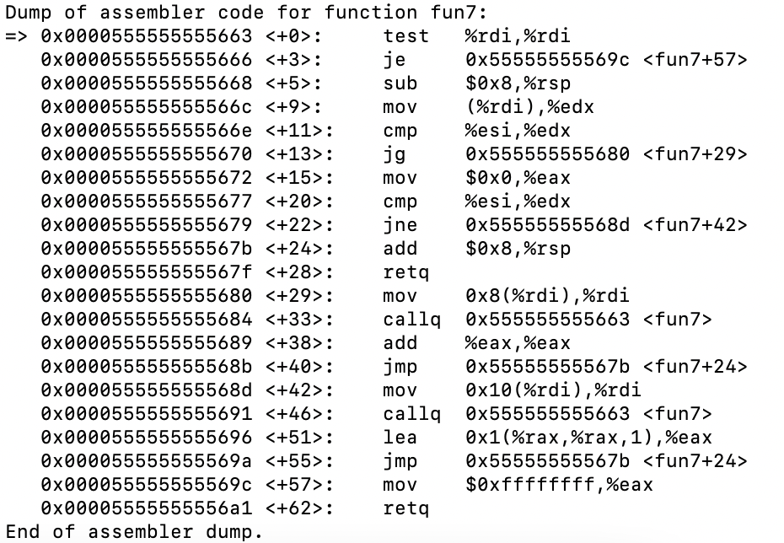

* Since there are only 15 values to test, we can input each one in its decimal form and try. Doing a preorder traversal of the tree, I found that 0x16, or 22, defuses the phase. We input 22 into the mysol.txt file.
* Clear breakpoints other than explode_bomb. Run with file input with command run mysol.txt. The bomb is defused.

**PART 2 ATTACK (target49)**

**Setting up:**

* objdump -d ./ctarget > ctarget_exc.txt generates executable disassembled code
* objdump -d ./rtarget > rtarget_exc.txt generates executable disassembled code
* objdump -D ./ctarget > ctarget_all.txt generates all disassembled code including data sections
* objdump -D ./rtarget > rtarget_all.txt generates all disassembled code including data sections

**Phase 1**

* Assembly code for touch1 using disas touch1

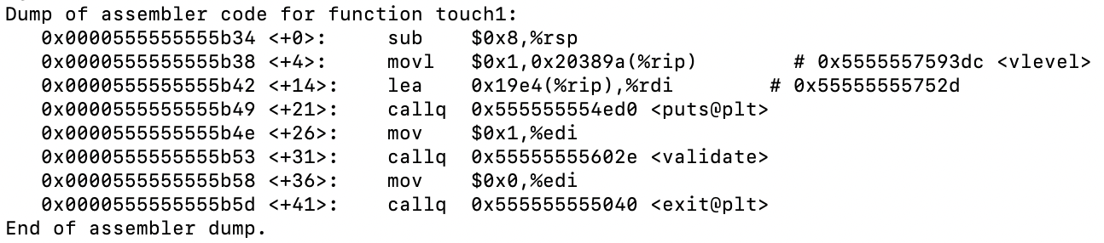

* Assembly code for getbuf using disas getbuf

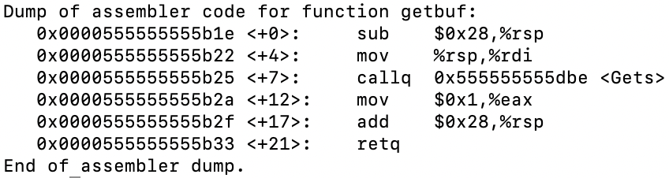

* Line +0 shows us that there is a buffer of 0x28, or 40 bytes that is allocated
* Since we now know the buffer size, we need to input 40 bytes of the buffer followed by the return address of touch1. The address of touch1 at runtime at line +0, which is 0x0000555555555b34
* We make a text file named touch1.txt and create the buffer using 5 lines of 00 00 00 00 00 00 00 00 (40/8=5), then put the address on the fifth line. Since our machine is in little endian, we must reverse the address.
* Run the program through hex2raw, which generates raw exploit strings:

./hex2raw < touch1.txt > touch1-raw.txt

* Run the raw file

r < touch1-raw.txt

**Phase 2**

* Disassemble touch2

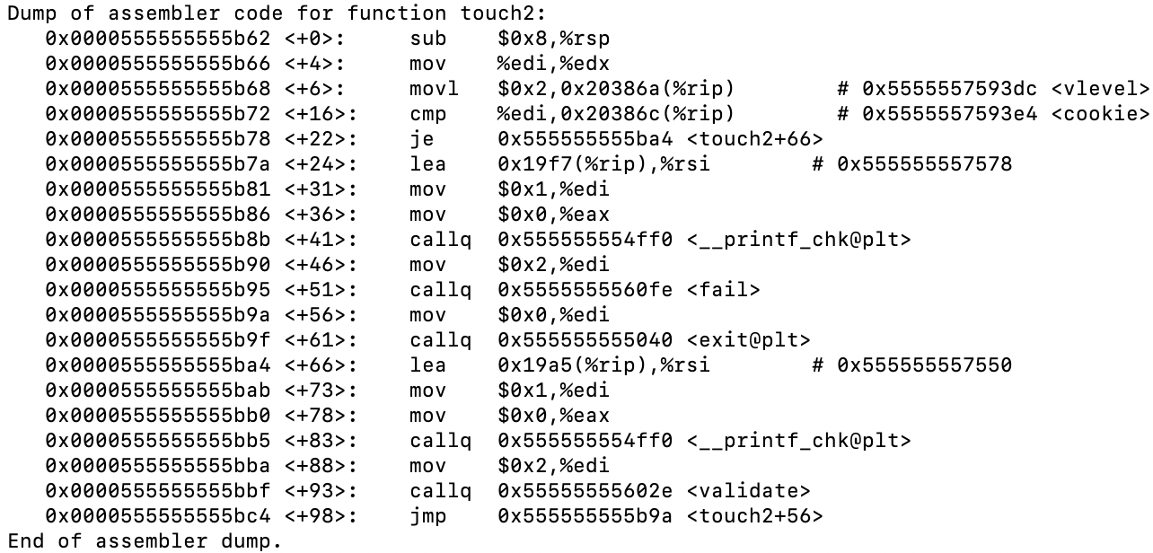

* We obtain our cookie with ./ctarget. It is 0x72791e2a. Our goal is to move our cookie into %rdi
* We can do this by writing a bit of assembly in a file called touch2.s

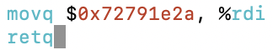

* Dissasemble with:



* To get:

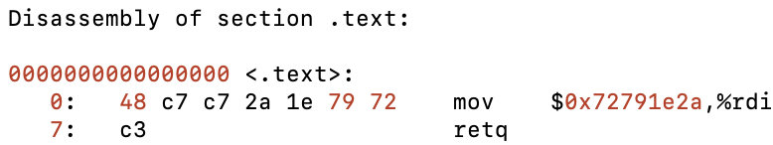

* The byte representation of the assembly code is 48 c7 c7 2a 1e 79 72 c3
* Now, we need to find the address of %rsp through getbuf. We run ctarget through gdb and set a breakpoint to get to getbuf. The assembly is the same as in phase 1.
* We step through using ni until it tells us to type a string and we type a random string that is long. Use x/s $rsp to access what is stored in the register and where in memory



* We make a text file called touch2.txt

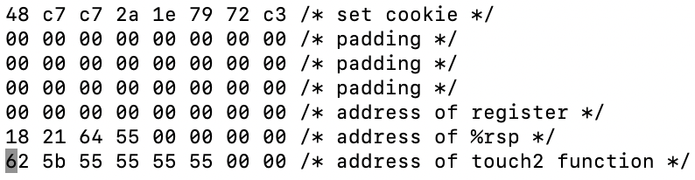

* Run the program through hex2raw, which generates raw exploit strings:

./hex2raw < touch2.txt > touch2-raw.txt

* Run the raw file

r < touch2-raw.txt

**Phase 3**

* Disassemble touch3

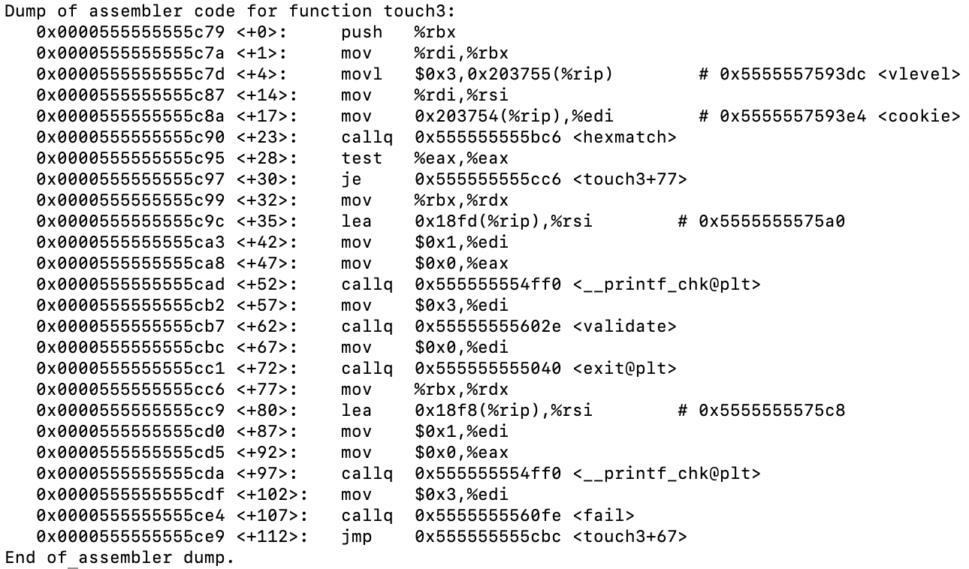

* Converting the cookie as a strinsg into hex, our cookie now becomes 37 32 37 39 31 65 32 61
* The instructions say that when hexmatch and strncmp are called, they push data onto the stack, overwriting portions of memory that held the buffer used by getbuf. This means we should put the cookie in the last line
* The total bytes before the cookie are buffer + 8 (return address of %rsp) + 8 (touch3)
  + 0x28 + 8 + 8 = 0x38 = 56
* Take the address of %rsp from from touch2 then add 0x38 to it 🡪 0x55642150
* Write a bit of assembly in a file called touch3.s

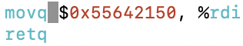

* Dissasemble with:



* To get:

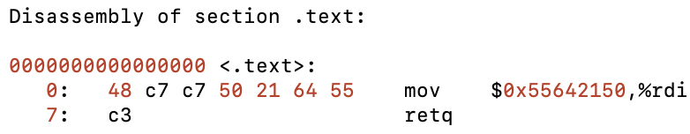

* Using the same steps from touch2, we can build our exploit string

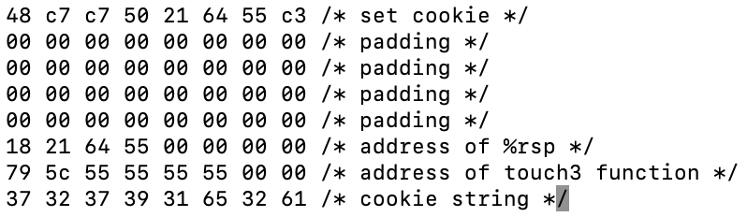

* Run the program through hex2raw, which generates raw exploit strings:

./hex2raw < touch3.txt > touch3-raw.txt

* Run the raw file

r < touch3-raw.txt

**Phase 4**

* We look into rtarget_exc.txt to access the gadget farm, which are the lines between start_farm and end_farm
* Instead of looking for popq %rdi since we can’t find it, we look for popq %rax
* The goal is to build something that looks like popq %rax

movq %rax, %rdi

ret

* Looking at the charts given in the specs, popq %rax is 58 and movq %rax, %rdi is 48 89 c7. We find two functions that we can use as our gadgets

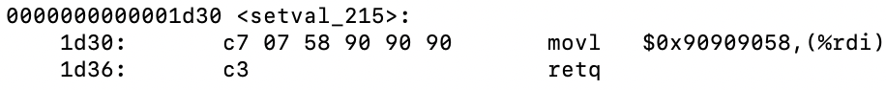

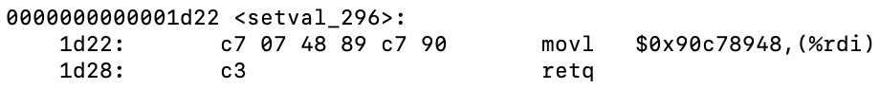

* Disassemble each function in gdb to get the correct memory address

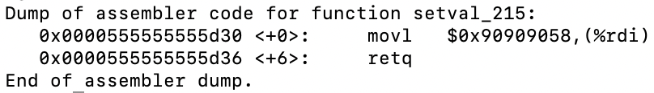

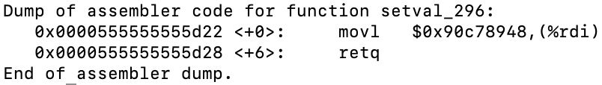

* setval_215 starts at 0x0000555555555d30, but 58 is present on the 3rd byte so we add 2 bytes to the address (0x0000555555555d32), and setval_296 starts at 0x0000555555555d22, but 48 is present on the 3rd byte so we add 2 bytes to the address (0x0000555555555d24)
* Now we can build our exploit string

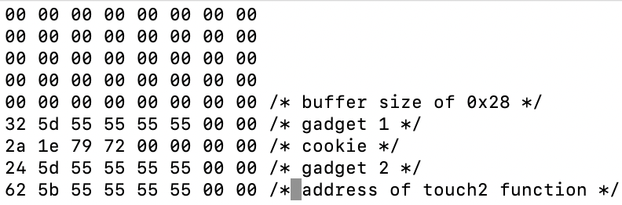

* Run the program through hex2raw, which generates raw exploit strings:

./hex2raw < touch4.txt > touch4-raw.txt

* Run the raw file

r < touch4-raw.txt

**Phase 5**

* We’ll need to use gadgets again for this one. A couple of steps will be necessary to use a different exploit method for touch3
* Put the cookie at %rsp and move into %rax (48 89 e0)

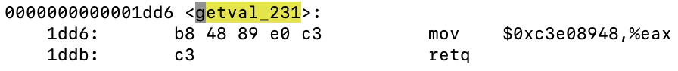

* Move %rax into %rdi (48 89 c7)



* Pop %rax (58)



* Copy %eax into %esi indirectly since we have no functions that can do it directly
  + %eax 🡪 %ecx (89 c1)

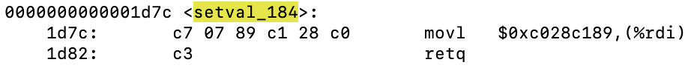

* + %ecx 🡪 %edx (89 ca)



* + %edx 🡪 %esi (89 d6)

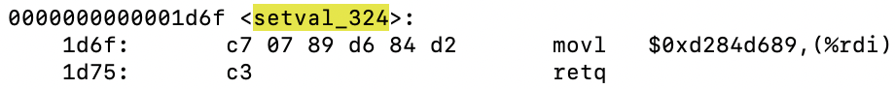

* Get address of add_xy

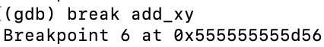

* Move %rax into %rdi (48 89 c7)



* All of the memory addresses of the functions were found by setting breakpoints then adding the offset from that address
* Now we can build our exploit string

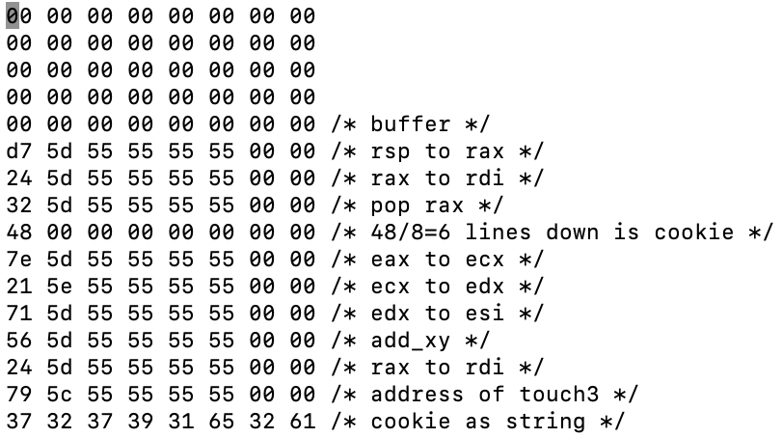

* Run the program through hex2raw, which generates raw exploit strings:

./hex2raw < touch5.txt > touch5-raw.txt

* Run the raw file

r < touch5-raw.txt